The National University of Lesotho
Department of Mathematics and Computer Science
Faculty of Science and technology

CS4433: Software Engineering
Task: Phase 1: Project planning and Management
‘Mafusi Motsoari
202322797

- Feasibility study: the proposed system is a moderated Learning Management System (LMS) for a secondary school. It will manage courses, assignments, submissions, marking, mark review and approval of marks by the HoD. The system will be developed as a C++17 application using SQLite and will operate on a single school computer or local network.

  - Technical Feasibility: the project is technically feasible because the required technologies are available and suitable for the system.
- The application will be developed using C++17.
- SQLite will be used for persistent data storage.
- CMake will be used to build the application.
- Git will be used for version control.
- A unit-testing framework such as GoogleTest or Catch2 will be used for testing
- A static analyzer such as cppcheck or clang-tidy will be used for code quality.
- The system does not require a web server or reliable internet connection because it is designed to work offline or on a local network.
- The school has old computers, so the system must also respond quickly with up to 800 students stored.
The project is technically feasible because the technologies are available, appropriate for the required functionality, and compatible with the school’s environment.
  - Operational Feasibility:
- User needs: teachers and students need a system that is straightforward to use. The system automates routine tasks like submitting assignments, calculating late penalties and tracking grade releases.
- Role Management: the system supports the core needs of administrators, lecturers, Head of Department (HoD) and students.
- Offline operation: operating fully offline ensures the school can run the system without interruption during internet failure.
The system is operationally feasible because its functions match the school’s processes and stakeholder needs
  - Economic Feasibility:
- Software Costs: all proposed development tools (C++ compiler, CMake, SQLite, GoogleTest, and Git) are open- source and free.
- Hardware costs: the system runs locally on existing school computers, requiring zero external server hosting fees or database licenses.
- The main costs would therefore be associated with existing computer equipment, installation, maintenance and stuff training rather than purchasing a completely new infrastructure.
The project is economically feasible because the required software infrastructure is relatively low cost and the system can operate using existing school resources.

  - Legal and Regulatory Feasibility:
    - Data Privacy: the system will store sensitive information such as student details, usernames and passwords, assignment submissions, marks, lecture feedback, and records of changes of marks. Therefore, the system must protect learner information and assessment records.
    - Security measure will include: storing passwords as salted hashes instead of plain text, role based access to control what each user can do, using parameterized database queries, keeping audit records for mark changes and restricting students from viewing marks before they released. The system will also record who changed a mark, when it was changed, the old value the new value and the reason for the change.
Therefore, the project is legally feasible provided that applicable data-protection and security requirements are followed.
  - Schedule Feasibility:
    - Timeframe vs workload: the project timeline is strictly 7 weeks. Completing all 8 life cycles phases from requirements engineering and UML/ERD design to C++17 development, SQLite integration, unity testing, CI pipelines, development, and maintenance can all presents an extremely high workload for a single developer.
    - As an individual project, all roles (project manager, architect, developer, QA tester and technical writer) are assigned to a single developer. Parallel task execution is impossible and there is no team redundancy.
- Work breakdown structure
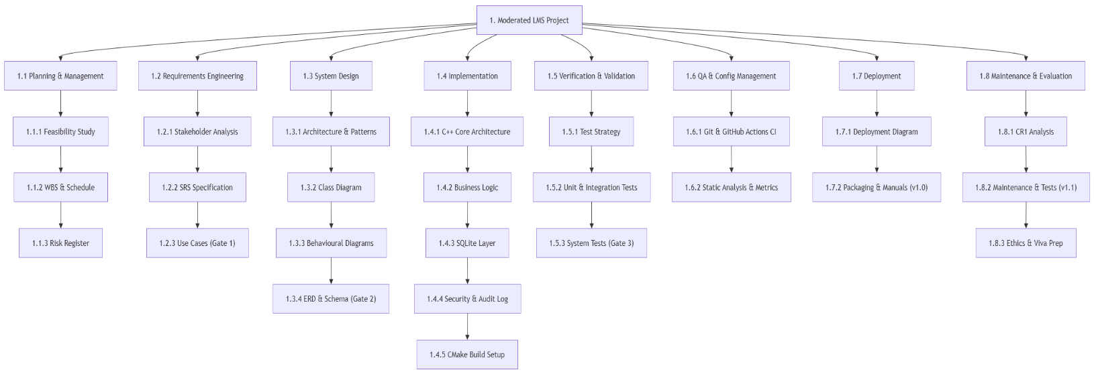
- Risk management: identifies, assesses, monitors and mitigates risks that could affect the planning, requirements, design, implementation, testing, deployment and maintenance of the LMS.
Risk ID | Risk Description | Category | Likelihood (1-5) | Impact (1-5) | Exposure (L × I) | Mitigation/ response | Risk owner | Review point
R01 | Leaked Passwords: passwords get stolon because they are saved in plaintext or weakly protected. | Technical | 2 | 5 | 10 | Always lock passwords using strong, standard encryption (salted hashes) so no plain passwords are ever saved. | Developer / student | Weekly; each phase gate
R02 | Conflicting requirements: teachers and the heads disagree on how grading works, causing confusion and delays. | project | 3 | 3 | 9 | Agree on the rules with everyone in writing during the first two weeks before coding starts. | Developer / student | Gate 1
R03 | Hidden date and time bugs: system clocks on school computers are set incorrectly, causing false late penalties or wrong submission times | Technical | 3 | 4 | 12 | Use absolute system UTC time stamps and allow teacher to adjust deadlines manually if local computer clocks are wrong. | Lead developer / student | Gate 2 and Gate 3
R04 | Computer memory leaks: unused memory or database connections stay open, making the program slow down or crash old school computers. | Technical | 3 | 4 | 12 | Use automated C++ memory managers(std::unique_ptr) and run code checking tools (cppcheck) to catch leaks before release. | Lead developer / student | Gate 2 and Gate 3
R05 | Hardware and connectivity failure(offline constraint): hardware crashes or unreliable network during deployment testing on legacy school PCs. | People | 4 | 3 | 12 | Build the entire application using lightweight C++ code and local SQLite storage so it works 100% offline without needing internet or fast hardware. | Developer / student | Gate 2 and Gate 3
R06 | Database Errors: the SQLite database crashes or loses data when multiple actions happen at once | technical | 2 | 5 | 10 | Write clean, safe database code that processes one task at a time using standard save commands. | Lead developer/student | Gate 2 and Gate 3

